Lethal acrodermatitis in Bull Terriers and Miniature Bull Terriers (LAD)
Lethal acrodermatitis Bull Terrier type is a severe, inherited skin disorder affecting Bull Terrier and Miniature Bull Terrier dog breed. The disorder has been for the first time described in 1986, and continuous researches haven recently identified the causative mutation of LAD. Similar disorder recognized in human patients is known as acrodermatitis enteropathica and it is an inherited disorder of zinc metabolism. Unlike acrodermatitis enteropathica, in LAD affected dogs additional zinc intake does not help in reducing the symptoms. Several, but all researches have identified reduced zinc levels in LAD affected dogs.

Symptoms
Lethal acrodermatitis affected puppies start to show clinical symptoms already in the first weeks of life. LAD is characterized by skin lesions on the feet and on the face, diarrhoea, bronchopneumonia, growth retardation and immunodeficiency. The skin lesions appear as tightly adherent scales, erosions or ulcerations with crusts, and are usually located on the feet, limbs, elbows and muzzle. With the progression of symptoms, hyperkeratosis of the footpads and deformation of the nails appears. Due to immunodeficiency, dogs often suffer from skin infections with Malassezia or Candida. The coat shows colour dilution in the pigmented areas. Affected dogs have an unusually arches hard palate, where food remains get stuck, decay and contribute to bad breath odour. Life expectancy is usually around 7 months of age, but the dogs are also commonly euthanized due to humane reasons, because of severe and painful lesions.

Genetics
Lethal acrodermatitis Bull Terriers type (LAD) is caused by a frameshift in the canine MKLN1 gene.
Healthy parents of an affected puppy are obligate heterozygotes, and therefore carry one mutant allele. Heterozygotes have no symptoms. Dogs homozygous for the mutation will display the symptoms of the LEMP. At conception, when mating two carrier dogs, each cub has a 25% chance of being affected, a 50% chance of being an asymptomatic carrier, and a 25% chance of being unaffected and not a carrier.

Test
A DNA test is available for this condition from Laboklin Laboratories at around £40 or as a bundle – see below.
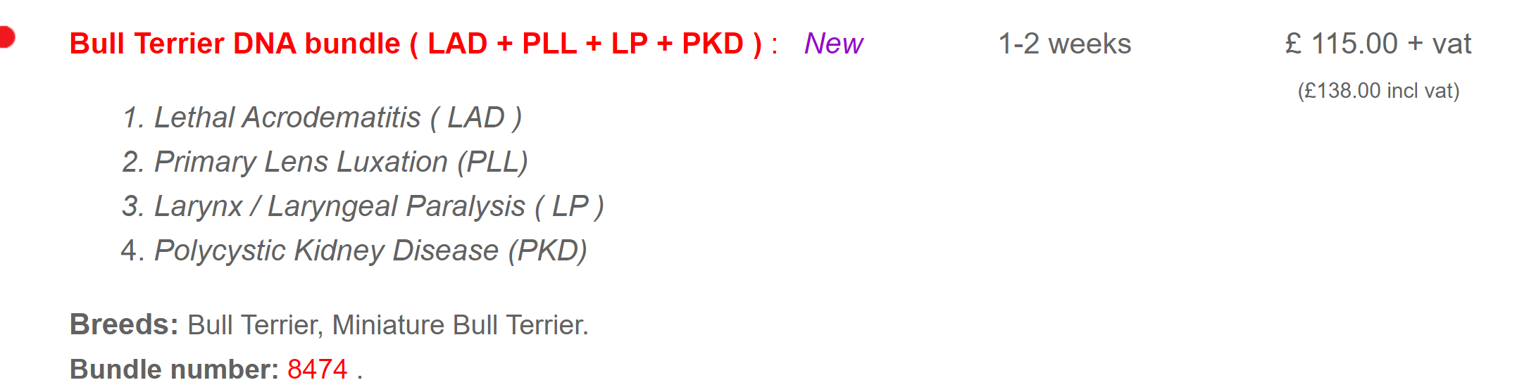

The Southern Miniature Bull Terrier Club encourages all its’ members to health test.

